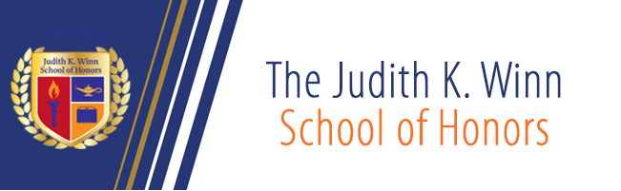

7th Annual Judith K. Winn School of Honors
Student Conference
April 28, 2017
Pitkin Education Center

Registration and light breakfast - Room C-313 8:45am-9:20am

SESSION ONE -- 9:30am -10:50am
Panel One: Issues in Contemporary America – Room C-321
Moderator - Dr. Andrew Tomko
“Pornography is Slavery” by Sara Wondergem
“Is Technology Negatively Affecting the Minds of our Society” by Alyssa Marie Aguilar
“The American Identity” by Cassandra Gilbert

Panel Two: Civil Liberties in the 21st century – Room C-303
Moderator – Prof. Mecheline Farhat
“All the Laws but One: Suspending Civil Liberties to Preserve our Country” by Amanda Karpinski
“Sex with a Porcupine” by Elda Pere
“Building the Perfect Beast – the many implications of IVF” by Allan Chapman

Panel Three: History of Genocide – Room L-347
Moderator - Dr. Sarah Shurts
“Irish Potato Famine: Irish versus English” by Juliana Oleksy
“The Relationship Between Genocide and War” by Colin Armstrong
“Genocide in the Ottoman Empire” by Michael Evans

Page Two

SESSION ONE -- 9:30am -10:50am
Panel Four: Literature – Room C-313
Moderator - Dr. Geoffrey Sadock
“Outsiders in the Novel” by Kathryn Colombo
“God is a Spirit” by Noemi Abundez
“Of Death and Paradox: Examining Sylvia Plath’s Lady Lazarus” by Allan Chapman

SESSION TWO --- 11:00am – 12:20pm
Panel One: Philosophy and Religion – Room C-313
Moderator: - Prof. Seamus Gibbons
“Contemplating Life” by Alexis Balkjy
“Conflict: the Cultivation of Inner Peace” by Allan Chapman
“Comparative Mythology and Monomyth in the Epic of Gilgamesh, Beowulf, and Marvel Comics, The Hulk” by Ryan Donovan

Panel Two: Gender Studies - Violence and Limitations – Room C-321
Moderator - Dr. Maria Makowiecka
“The Reasons Behind the Silence of Sexual Violence” by Deidra I. M. Womack
“The Limited Lives of Poor Women in Albania” by Sibora Peca
“Adding to the Definition of Genocide” by Michelle McMillan

Panel Three: Interdisciplinary Studies: Society and Self – Room L-347
Moderator – Dr. Mi Ahn
“Science Fiction as Societal Mirror: Identity, Marginalization and Autonomy in Westworld” by Sean Mooney
“The Singer Solution to World Poverty” by Nidaa Ombali
“Age is just a Number” by Vincent Pezzano

Page Three
SESSION TWO --- 11:00am – 12:20pm
Panel Four: Social Science - Age and Education – Room C-303
Moderator: - Dr. Anne Maganzini
“Nontraditional Students and their Performance in College” by Fernanda Jimenez Cano
“The Importance of Applying Study Skills… in the Studying Process” by Doreta Biba
“Effects of Adulthood Responsibility on Long-Term Goals of Emerging Adults”
by Aamir Ali

Luncheon - C-211 12:30pm -2:00pm

Welcome: - Seamus A. Gibbons, Director of Judith K. Winn School of Honors
Luncheon Speaker: - Former JKW Honors Graduate - Ana Cassandra De Jesus
Presentations: - Dr. William P. Mullaney, Vice-President, will present all student participants with Conference Certificates.

